# Create the Monthly KPI Status Report Procedure

Continuous Performance Enhancement

**Purpose**

The Monthly KPI Status Report.is a power point presentation that is used to summarize SLM stats for Senior Management. This report is rolled up with other Service Delivery Team reports. It is very important that the stats shown in this power point agree with and support the other Service Delivery team’s stats. The Monthly KPI Status Report is published on the fourth business day of the current month.

**Related Policy**

* [IT Service Management Policy](https://sharepoint.jackson.com/sites/integrity/_layouts/15/WopiFrame.aspx?sourcedoc=%7be34fe42a-654a-469a-9d38-6612f00486dc%7d&action=view)

**Audience**

The following groups are responsible for adhering to this document:

* Continuous Performance Enhancement

**Procedure**

|  |  |  |
| --- | --- | --- |
| Step | | Action |
| 1 | Locate the previous month’s *KPI Status Report* at the following location:  [O:\Service Delivery\Service Level Management\Reporting\YYYY\Monthly KPI Reports Power Point](../../../Reporting)   1. Make a copy of the previous month’s report. 2. Rename the report to include the current month and year.    * The naming standard is as follows:  * Service Level Management Month Year.pptx   ***Note:*** *Before working on the KPI Status Report it is expected that all of the Missed or Breached SLAs for the previous month have been addressed.*  For more information see:  [SLM Reviewing the Daily SLA Report Procedure](../../SLA/Reports/SLM_Reviewing%20the%20Daily%20SLA%20Report.docx) | |
| 2 | **Header Page**  Edit the following information on the first page (See ***Appendix A*** for example).   * Submitted by: Type in your name * Date: Type in the date that the report is being prepared.   Skip the second page (Summary). This will be covered in Step 10. | |
| 3 | **Tier 1 Applications.**  The first few pages of the *KPI Status Report* are for the Tier 1 applications. (See ***Appendix C*** for example).  ***Note****: The KPI Status Report contains thirteen months of SLA information.*   1. On the first page of the Tier 1 Applications, place the cursor on the bottom row of the second from last column (showing data from twelve months ago) on the page. 2. Drag the cursor to the top of the third column (showing data from two months ago, including the month and year). 3. Right click and select “Copy”. 4. Place the cursor in the bottom row of the last column (showing data from thirteen months ago). 5. Drag the cursor to the fourth column (showing data from three months ago, including the month and year). 6. Right click and select “Paste / Keeping Format”. The previous twelve months should now appear in the fourth through last column. 7. Remove all data from the first column. 8. Rename the first column to the be the previous month and year. 9. Ensure that the cell colors for the previous twelve months are correct. View the previous month’s *KPI Status Report* to compare and correct the cell colors if necessary.  * Green – SLA Target was met or exceeded threshold for the month. * Red – SLA Target breached threshold for the month. * Grey – SLA Target is being baselined or negotiated (see Step 7 below). * White – Measurement was not required or is no longer required.  1. Use the Daily SLA Report dated for the last day of the previous month to add the percentages in the first column of the report. It is located at:   [O:\Service Delivery\Service Level Management\Reporting\Daily SLA Report](../../../Reporting/Daily%20SLA%20Report)   * Select the previous month’s folder and the SLA Report with the last date of the month on it. * The current SLA Report is broken down by Business Units. The applications do not appear in alphabetical order. Use the “Find” option under “Edit” in the PDF document to search for each application.   ***Note:*** *Some applications may appear more than once throughout the report as different Business Units use the applications and may have different Service Targets. Always ensure that the “Target:” matches the percentage found in the “SLA Target” found on the KPI Status Report.*  ***Example:*** *Accounting Audit on the KPI Status Report has an SLA Target of*  *99.0%.*    *Accounting Audit appears on the SLA Report more than once. Find the entry that has a Target of 99.00% and use the “Percentage of SLA Met” to add data to the corresponding cell in the KPI Status Report.*       1. Repeat a) through j) of the for the remaining pages of the Tier 1 Applications. | |
| 4 | | **Additional Tier 1 Systems Added…** This section is for Tier 1 applications that an SLA has been requested for. Research, negotiations with the business, SIG, or JTS is being conducted, or final approval is pending for these applications. Monitors will not have been set up for these applications yet, so they are being manually monitored via Remedy Incident tickets. The cells will remain grey for this section of the report. (See *Appendix D* for example).  1. Repeat a) through h) of Step 3, but on the “Additional Tier 1 Systems Added” pages. 2. Use the monthly percentages from the [*Tier 1 Tracking YYYY*](../../../Projects/Building%20SLAs/Tier%201%20Information%20(non%20MDD)) and [*Deliverables Monitoring*](../../../Projects/Building%20SLAs/Deliverables%20Monitoring) spreadsheets to acquire the data needed to fill in the first column.   For more information see:  [Manually Monitor Services Procedure](../../Monitoring/Manually%20Monitor%20Services%20Procedure.docx)  [Manually Monitor Deliverables Procedure](../../Monitoring/Manually%20Monitor%20Deliverables%20Procedure.docx)   1. The SLA Target percentage will have a blue or red **\*** next to it. The color indicates the following:  * Blue – SLA Target is pending finalized request from Stakeholders. * Red – SLA Target has been received from Stakeholders and is being baselined. Final approval is pending results of baselining per the SLM Process.   + If an SLA Target percentage has not been decided on yet, the cell will be populated with “TBD”.  1. If the application has a red * next to it and has been baselined for nine months do the following:  * If the SLA Target has been 100% for all nine months of the baseline period: * Insert a row in the “Tier * Application” page where the application is to be moved. Applications appear in alphabetical order. * Cut the entire row for the application to be moved from the “Additional Tier * Systems Added…” page. * Paste the data into the blank row that was inserted on the “Tier * Applications” page. * Update the cells containing the percentages to green or white. * If the SLA Target has not been 100% for all nine months of the baseline period: * Calculate the baseline percentage using the “Baselined Services” spreadsheet located at:   [O:\Service Delivery\Service Level Management\Reporting\YYYY\Monthly KPI Reports Power Point](../../../Reporting)  For more information see Step 7 of the:  [Service Level Management Process](../../../SLA%20Information/SLM%20documents%20for%20announcements/SLA/SLM_Service%20Level%20Management%20Process.doc)   * If the baseline percentage meets the expected SLA Target percentage insert   a row in the “Tier * Applications” page where the application is to be moved to. Applications appear in alphabetical order.   * Cut the entire row for the application to be moved from the “Additional Tier * Systems Added…” page. * Paste the data into the blank row that was inserted on the “Tier * Applications” page. * Update the cells containing the percentages to green, red, or white. * If the baseline percentage does not meet the expected SLA Target percentage, notify SLM Management to discuss what will be done to have the SLA Target percentage changed. |
| 5 | | **Tier 2 Applications**  The next section of the *KPI Status Report* is for the Tier 2 Applications. (See ***Appendix E*** for example).  Repeat a) through k) of Step 3, but on the “Tier 2 Applications" pages. |
| 6 | | **Additional Tier 2 Systems Added…**  This section is for Tier 2 applications that an SLA has been requested for. Research, negotiations with the business, SIG, or JTS is being conducted, or final approval is pending for these applications. Monitors will not have been set up for these applications yet, so they are being manually monitored via Remedy Incident tickets. The cells will remain grey for this section of the report. (See ***Appendix F*** for example)   1. Repeat a) through h) of Step 3, but on the “Additional Tier 2 Systems Added” sections. 2. Use the monthly percentages from the [*Tier 2 Tracking YYYY*](../../../Projects/Building%20SLAs/Tier%202%20Information%20(non%20MDD)/Spreadsheet%20Information) and [*Deliverables Monitoring*](../../../Projects/Building%20SLAs/Deliverables%20Monitoring) spreadsheets to acquire the data needed to fill in the first column.   For more information see:  [Manually Monitor Services Procedure](../../Monitoring/Manually%20Monitor%20Services%20Procedure.docx)  [Manually Monitor Deliverables Procedure](../../Monitoring/Manually%20Monitor%20Deliverables%20Procedure.docx)   1. Repeat c) and d) from Step 4. |
| 7 | | **Reports and File Deliveries / Infrastructure**  This section of the *KPI Status Report* is for deliverables, SLAs monitored via batch jobs for report and file deliveries. The Infrastructure services are used by all Business Units and appear in their own section of the SLA Report. Because there are only a few items, this section can be added to the bottom section of the “Reports and File Deliveries” pages. (See **Appendix G** for example).   1. Repeat a) through k) of Step 4, but on the “Deliverable” pages. 2. Repeat a) through k) of Step 4, but on the “Infrastructure” section. |
| 6 | | **Other KPI Business Applications (Tier TBD)**  Applications that have not been tiered, or possibly had an incorrect tier assigned to it, are listed in this section of the *KPI Status Report*. (**See Appendix H** for example).  Repeat a) through k) of Step 1, but on the “Other KPI Business Applications” pages. |
| 7 | | **DTCC Transactions**  This section is for transactions performed between Jackson and the DTCC vendor. (See ***Appendix I*** for example).   1. Repeat a) through h) of Step 1, but on the “DTCC Transactions” section. 2. The monthly percentage is calculated within the DTCC Transactions spreadsheet, via information from the DTCC Portal Websites. The spreadsheet is located at the following location:   [O:\Service Delivery\Service Level Management\Reporting\YYYY\Daily SLA Report\Month\DTCC Transactions](\\\\jacksonnational.com\\SHARE\\hq\\vol3\\share\\Service Delivery\\Service Level Management\\Reporting)   1. Use the spreadsheet from the previous month to acquire the monthly percentages.   For more information see:  [Monitor DTCC Portal Transactions Procedure](../../Monitoring/Monitor%20DTCC%20Portal%20Transactions%20Procedure.docx) |
| 8 | | The final page of the *KPI Status Report* is for OLA Breached Tickets. (See ***Appendix J*** for example).   1. Update the monthly values and the 13 Month total values:    1. In the “13th Month Total” column, subtract the number from the second column featuring data from the oldest month column (example “Dec 2016) presented. Repeat this for each row.    2. Cut the oldest month column.    3. Insert a row between the last month and the 13-month total column.    4. Rename the header to the new month (example would be “Jan 2018”).  |  |  |  |  |  |  |  |  |  |  |  |  |  |  |  | | --- | --- | --- | --- | --- | --- | --- | --- | --- | --- | --- | --- | --- | --- | --- | |  | Dec 2016 | Jan 2017 | Feb 2017 | Mar 2017 | Apr 2017 | May 2017 | Jun 2017 | Jul 2017 | Aug 2017 | Sept 2017 | Oct 2017 | Nov 2017 | Dec 2017 | 13 Month Total | | Total Incident Tickets PGDS | 6678 | 8751 | 8369 | 9984 | 8765 | 12999 | 14094 | 18636 | 11706 | 9248 | 12196 | 13404 | 10751 | 145581 |  |  |  |  |  |  |  |  |  |  |  |  |  |  |  |  | | --- | --- | --- | --- | --- | --- | --- | --- | --- | --- | --- | --- | --- | --- | --- | |  | Jan 2017 | Feb 2017 | Mar 2017 | Apr 2017 | May 2017 | Jun 2017 | Jul 2017 | Aug 2017 | Sept 2017 | Oct 2017 | Nov 2017 | Dec  2017 | Jan  2018 | 13 Month Total | | Total Incident Tickets PGDS | 8751 | 8369 | 9984 | 8765 | 12999 | 14094 | 18636 | 11706 | 9248 | 12196 | 13404 | 10751 |  | 138903 |  1. Use the summary totals listed on page 2 of the *Monthly OLA Breached Report MM YYYY* for the previous month at:   [O:\Service Delivery\Service Level Management\Reporting\YYYY\Monthly OLA Breached Reports](../../../Reporting)   1. Enter the corresponding numbers from the *Monthly OLA Breached Report MM YYYY* summary into the new column:  * Count of *JTS Incident Tickets with OLAs* attached is used for the “Total Incident Tickets JTS” cell.      * Count of *JTS Incident Tickets with Breached OLAs* is used for the “Total Breached Tickets” cell.      1. Use the *Monthly Totals by Priority MM YYYY* report to populate the cells for priority “Assignment” and “Resolution” breaches. The repot is located at:   [O:\Service Delivery\Service Level Management\Reporting\Monthly OLA Breached Reports\Calculated for KPI](../../../Reporting/Monthly%20OLA%20Breached%20Reports/Calculated%20for%20KPI)     1. Add the new column’s number for each row to the corresponding “13 Month Total” cell to produce new 13 Month Totals. 2. Calculate the percentage for the “% Breached Tickets” row for the new column and the % Breached Tickets for the “13 Month Total” column using the following formula:   **Total Breached Tickets / Total Incident Tickets PGDS Total X 100%** |
| 10 | | **SLM Status Report Summary Page**  Update the second page of the *KPI Status Report* with SLA and OLA summary information. (See ***Appendix B*** for example).   1. If any of the SLAs are in red for the month, add the details of the Missed SLA from the Monthly SLA Report to the second page. This should include:  * The Service Target / Metrics information * Any days in which the SLA was missed during the previous month, complete with comments.   ***Example:*** Service Level Agreement KPI  ***Commissions Checks Fin.*** *Target : 98.00% Mon-Fri 11:00*  *04-04-2017, Tue 0.00% INC1220979 Month / Quarter End*  *processing.*   * If an application had several outages, add a new slide for each breached SLA. Use the information from the incident tickets to explain in detail what the error, impact, and resolution were.  1. If no SLAs were breached, add the following comment to the “Service Level Agreement KPI” section: *No KPI SLAs were breached.* 2. Add a comment regarding the Breached OLAs, using the information from Page 7 of the KPI report.   ***Example:***   * Operational Level Agreement KPI   + OLA Breached Incidents 7.63% - There was a total of 8,765 JTS tickets with service target OLAs and 669 of those were breached.  1. Add any pertinent comments regarding SLAs / OLAs.   ***Example:***   * Additional Information   + 91 out of 102 Tier 1 MDDs are completed     - 21 out of 21 Tier 0 MDDs are completed |
| 11 | | **Publish the Report**   1. On the fourth business day of the current month, the KPI Status Report is published to Sharepoint for Service Delivery management to review. The SLM Manager will have to publish this report at the following location:   [https://sharepoint.jackson.com/sites/itsmsd/Status%20Reports/_layouts/15/start.aspx#/SitePages/Home.aspx](https://sharepoint.jackson.com/sites/itsmsd/Status%20Reports/_layouts/15/start.aspx" \l "/SitePages/Home.aspx)   1. On the seventh business day of the current month, the KPI Status Report is also published to SharePoint at the following location:   [Monthly Reporting/SLM/Monthly SLA Information/Monthly KPI Report/YYYY](http://docs.jackson.local/it/sites/rs/Monthly%20Reporting/Forms/current.aspx?RootFolder=%2Fit%2Fsites%2Frs%2FMonthly%20Reporting%2FSLM%2FMonthly%20SLA%20Information%2FMonthly%20KPI%20Report&FolderCTID=0x0120008757BF0A693734429A00C5DB64BC5778&View=%7B240B9B17%2D0630%2D4691%2DAA51%2DE27EC38CF00E%7D)   1. If any updates were made to the KPI Status Report between the fourth and seventh business days, notify the SLM Manager to re-publish the report at the Sharepoint location in a). 2. The link from SharePoint for the KPI Status Report published on the seventh business day of the month is sent as part of the email for the Monthly SLA Report.   For more information see:  [SLM Monthly SLA Report Procedure](SLM%20Monthly%20SLA%20Report%20Procedure.docx) |

**APPENDIX A – Header Page**

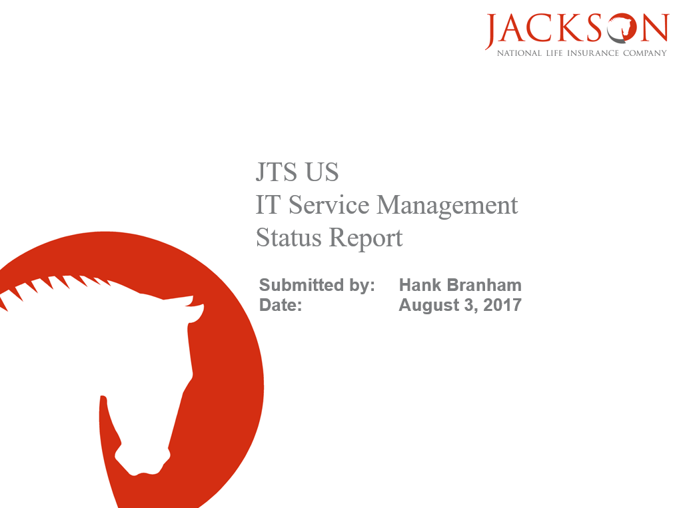

**Appendix B – Summary Page Example**

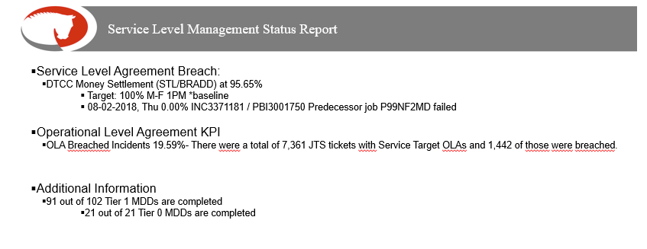

**Appendix C – Tier 1 Business Applications**

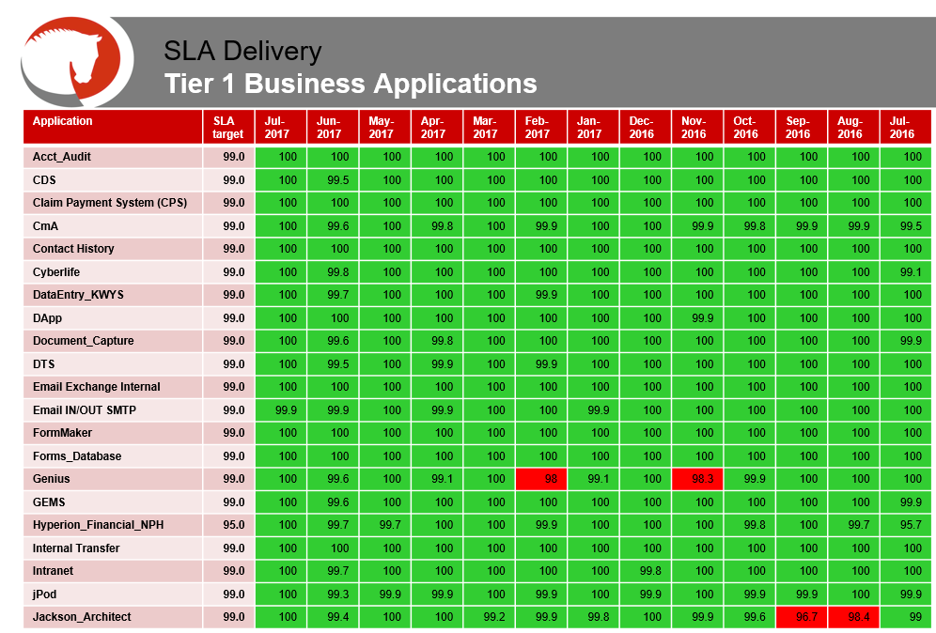

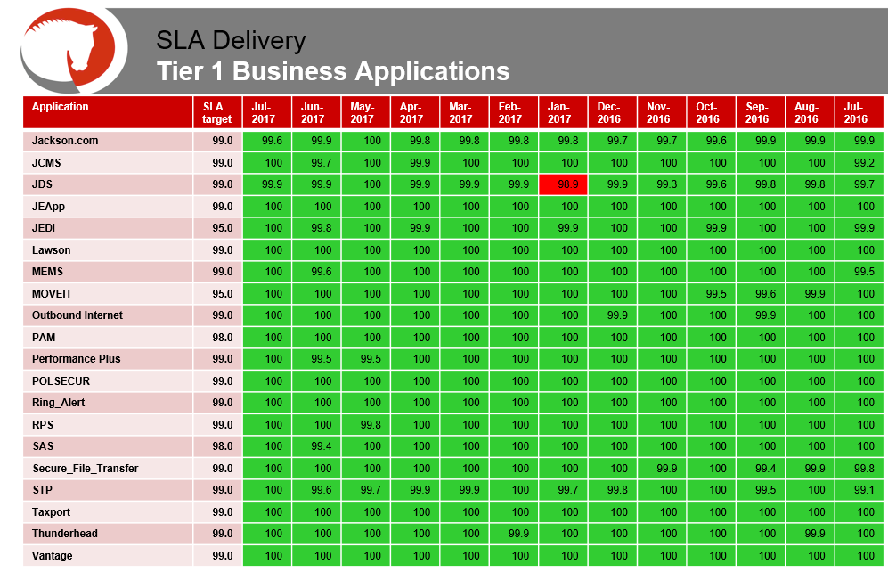

**Appendix D – Additional Tier 1 Systems Added… \***

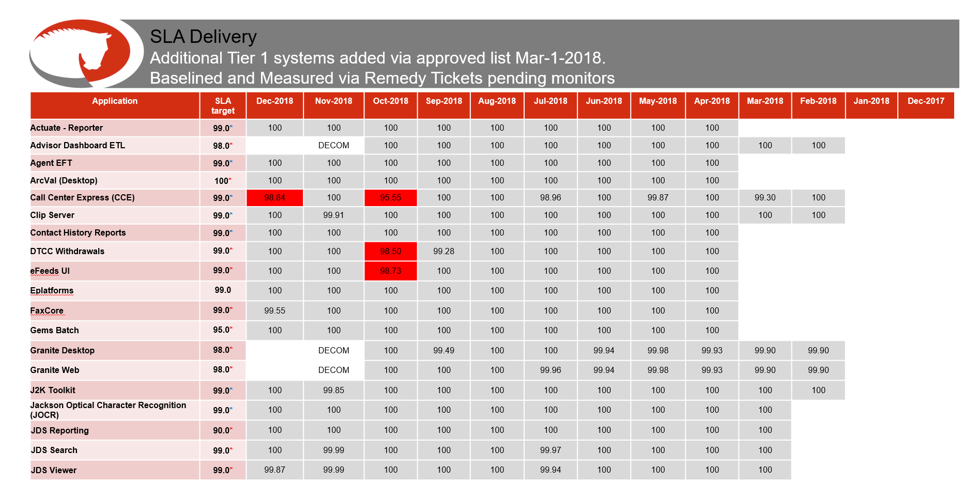

*This page may not be needed if there are no services being baselined.

**Appendix E – Tier 2 Business Applications**

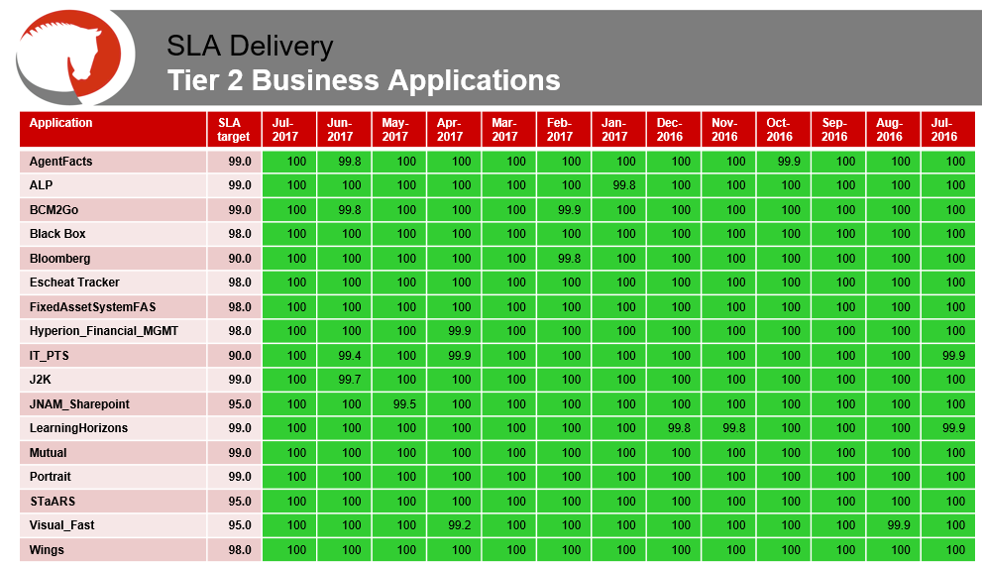

**Appendix F – Additional Tier 2 Systems Added… \***

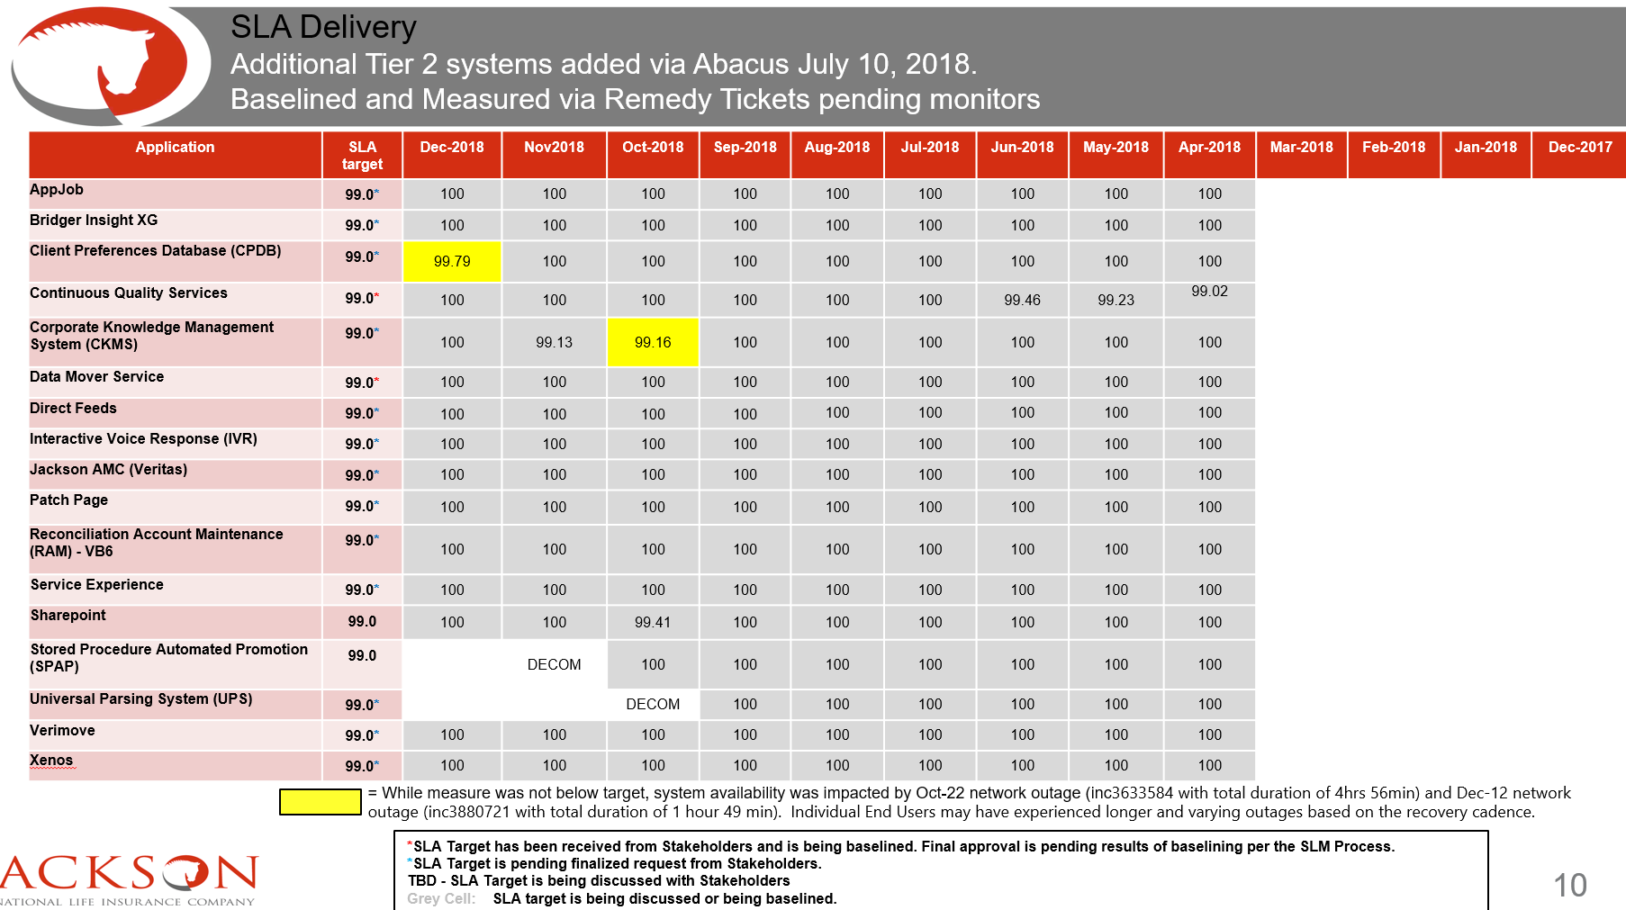

*This page may not be needed if there are no services being baselined.

**Appendix G – Reports & Deliveries / Infrastructure Example**

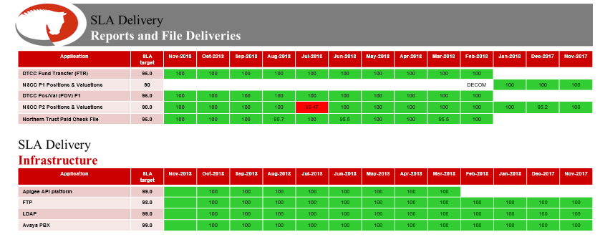

**Appendix H – Other KPI Business Applications (Tier TBD)**

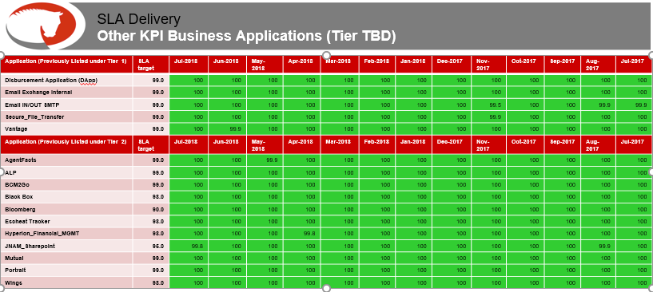

**Appendix I – DTCC Transactions**

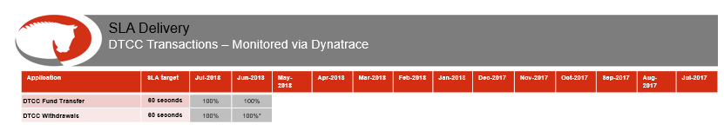

**Appendix J – OLA Breached Tickets**

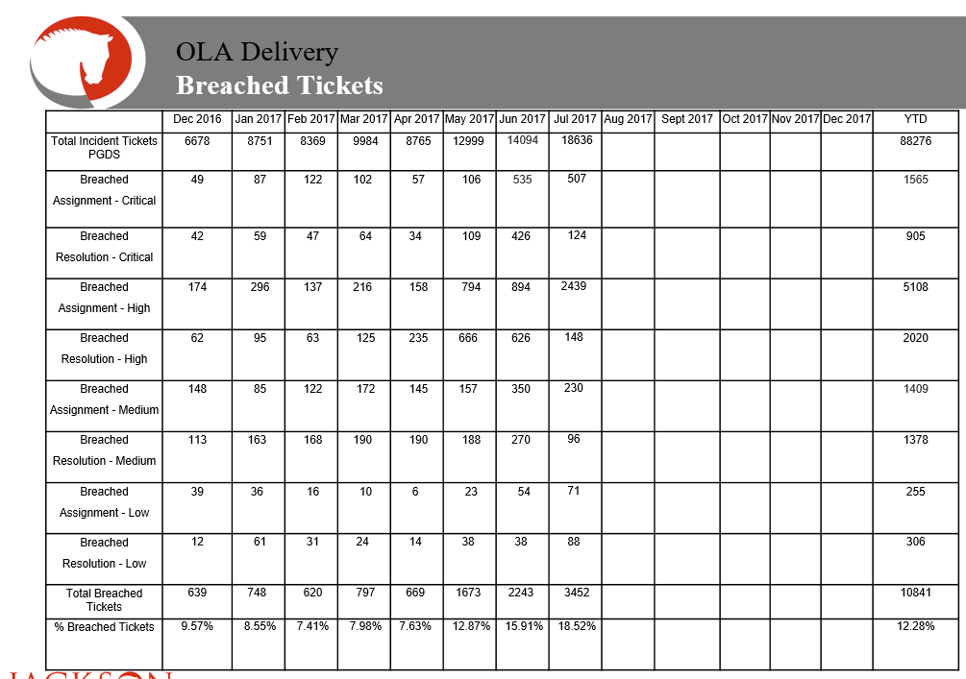

**Appendix K – Monitoring Procedures**

Some of the applications and deliverables are monitored separately from normal methods. Use these procedures for the following applications / deliverables:

* [**Commission Checks**](../../Monitoring/Monitor%20SLA%20for%20Commission%20Checks.docx) **–** Manually Monitor SLA For Commission Checks Procedure
* [**DTCC Transactions**](../../Monitoring/Monitor%20DTCC%20Portal%20Transactions%20Procedure.docx) – Monitor DTCC Portal Transactions Procedure
* [**Manually Monitor Services**](../../Monitoring/Manually%20Monitor%20Services%20Procedure.docx) – Services that have been requested but have not been fully approved and /or a monitor has not yet be built yet.
* [**Manually Monitor Deliverables**](../../Monitoring/Manually%20Monitor%20Deliverables%20Procedure.docx) – Deliverables that are being monitored but have not been fully approved.
* [**MyAccess (Remote Access**)](../../Monitoring/Monitor%20SLA%20for%20MyAccess%20Procedure.docx) – Monitoring SLA for MyAccess Procedure
* [**New Business Desktop**](../../Monitoring/Monitor%20NBD%20Metric%20Procedure.docx) – Monitor NBD Metric Procedure
* [**Virtual Desktop**](../../Monitoring/Monitor%20SLA%20for%20Virtual%20Desktop%20Procedure.docx) – Monitoring SLA for Virtual Desktop Procedure

**Modification**

The following associates can make modifications to this document:

* Director, Continuous Performance Enhancement
* Vice President, Continuous Performance Enhancement
* Chief Technology Officer, JET

|  |  |
| --- | --- |
| Continuous Performance Enhancement | |
| Responsible Party: CPE Metrics Approving Authority: Bali Bodeddula, Director, JET Continuous Performance Enhancement | Date Created: 08/08/2017 Last Modified: 01/11/2019 Last Reviewed: |